# Acceptance Criteria Testing

## Story ID 1

User Story: As the owner or coordinator I want to be able to see and manage a list of contacts so that I can contact them if need be.

* I can view a list of contact information, such as email and phone numbers.
* I can manipulate the contact list by adding and removing contacts from the list.

I can view a list of contact information.

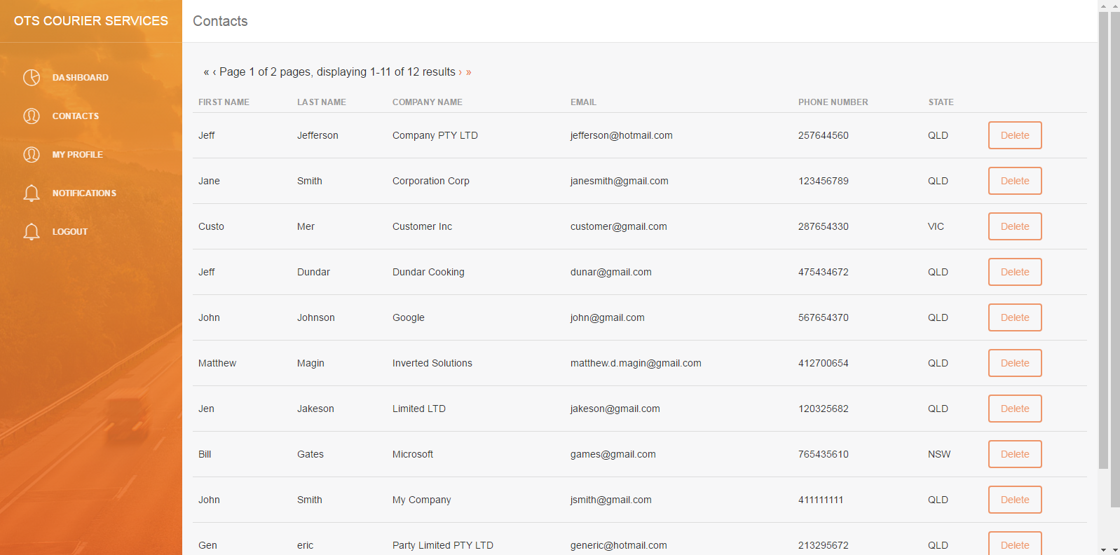

I can click on a contact and view an individual’s information.

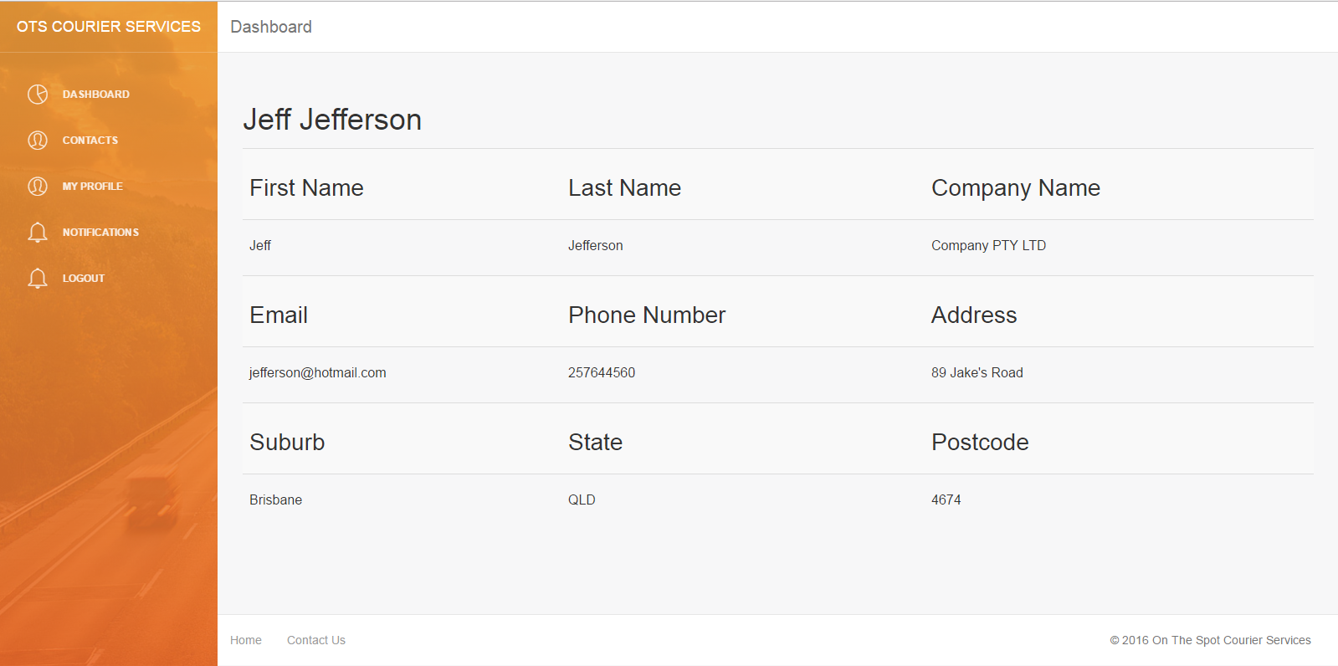

I can remove a contact



I am prompted to confirm the deletion.

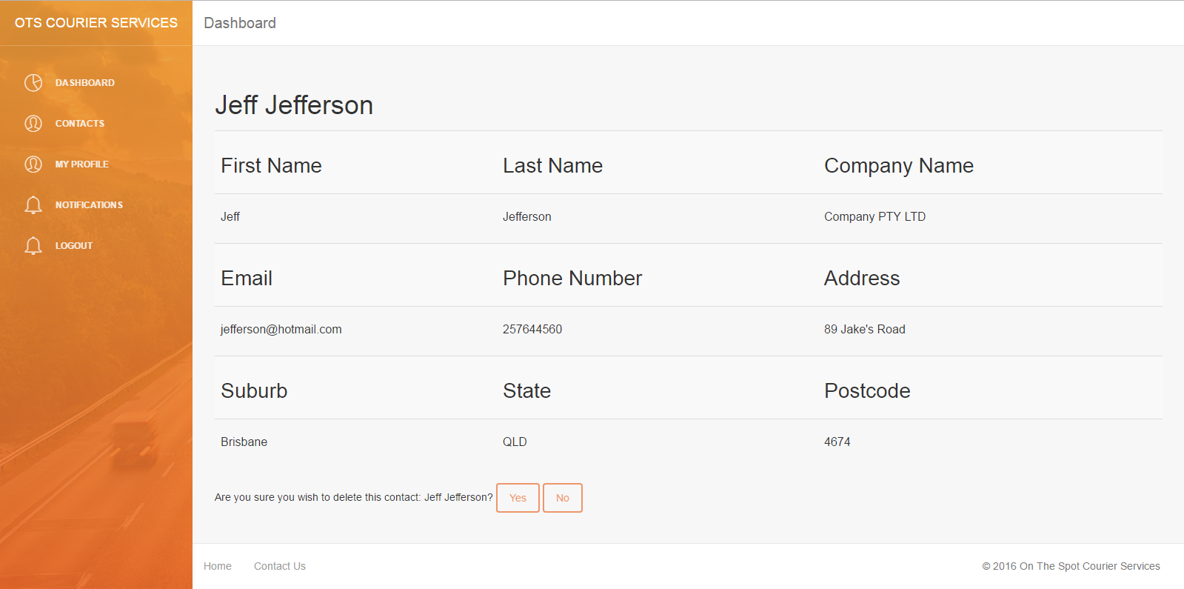

Jeff Jefferson is gone

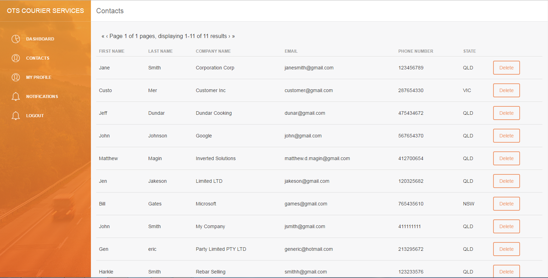

NOT IMPLEMENTED → ADD CONTACT

During development, it was found since the current iteration of the contacts page draws from the customers table and adding a contact would effectively create an account for them (complete with a password) either this function needs to be available to the customers themselves or be retooled to use a different table.